# Required Assignment 9.2: Creating the Van Westendorp Price Sensitivity Meter

**Anupam Shringi**

**Suggested time:** 120 minutes.

**Assignment Instructions**

The Van Westendorp model focuses on the perceived value of the product rather than the absolute price by asking a set of price perception questions.

For this assignment, take a product or a business of your choice. Ask the following four questions to potential customers (or friends, family, colleagues, or classmates) to create the Van Westendorp Price Sensitivity Meter.

1. At what price is the product too cheap that you start doubting its quality?
2. At what price is the product a good bargain?
3. At what price will you buy the product for its quality even if it's not a bargain?
4. At what price is the product unaffordable?

As the submission for this assignment, talk about the product you chose, describe the process of creating the price sensitivity meter, your findings, and the conclusions.

***Note****: This is a required assignment and counts towards programme completion.*

**Step 1: Create a survey for with the 4 questions to assess the price sensitivity of the respondents and solicit responses:**

Screenshots of the survey:

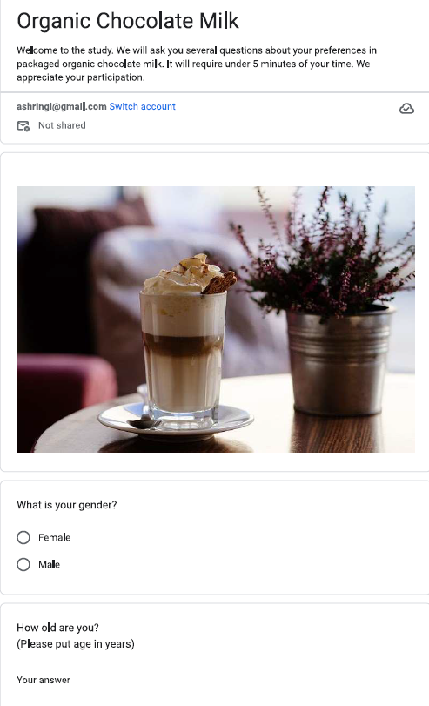

**Link to the survey:**  
<https://forms.gle/QuqPBAMM4BxCYmKZ9>

**Findings:**

1. **Response summary:**

A total of 40 responses with the maximum value of 100 for too expensive and a minimum value of 1.

1. **Cumulative histogram of the 4 questions:**

Maximum value is capped at INR 100 and number of bins is fixed at 25.

1. **Van Westendrop’s Price sensitivity Meter plot:**

**PME**

**PMC**

**- PMC: point of marginal cheapness is the intersection of green and orange curve. For the above curve it’s close to INR 25**

**- PME: point of marginal expensiveness is the intersection of blue and red curve. For the above curve it’s close to INR 39**

Acceptable price range is between point of marginal cheapness (PMC) and point of marginal expensiveness (PME). **Optimal price is close to INR 32.**